|  |  |
| --- | --- |
| **Name:- Aryan Dilipbhai Langhanoja** | **Roll Number:- 92200133030** |
| **Subject Name and Code:-** Foundation Skills On Sensor Interfacing (01CT1103) | **Date of Experiment:- 11-11-2022** |

|  |  |
| --- | --- |
| Task:- |  |

* Interface PIR sesnor with arduino and turn on the led based on the motion detection.

|  |  |
| --- | --- |
| Components: |  |

* Arduino Uno R3
* LED
* Jumper Wires (Male To Male)
* PIR Sensor.
* Bread Board
* Laptop Or PC

|  |  |
| --- | --- |
| About the Project:- |  |

* In thisproject, we are going to interface PIR Sensor with Arduino. PIR Sensor Has Three pins. One Is VCC pin which is connected to +5V of Arduino. One Pin Ground which is Connected to GND of Arduino. And One is output Pin which is connected to One of the digital Pin of Arduino.
* Generally, PIR sensor can **detect animal/human movement in a requirement range**. PIR is made of a pyroelectric sensor, which is able to detect different levels of infrared radiation. The detector itself does not emit any energy but passively receives it. It detects infrared radiation from the environment.

|  |  |
| --- | --- |
| Schematic:- |  |

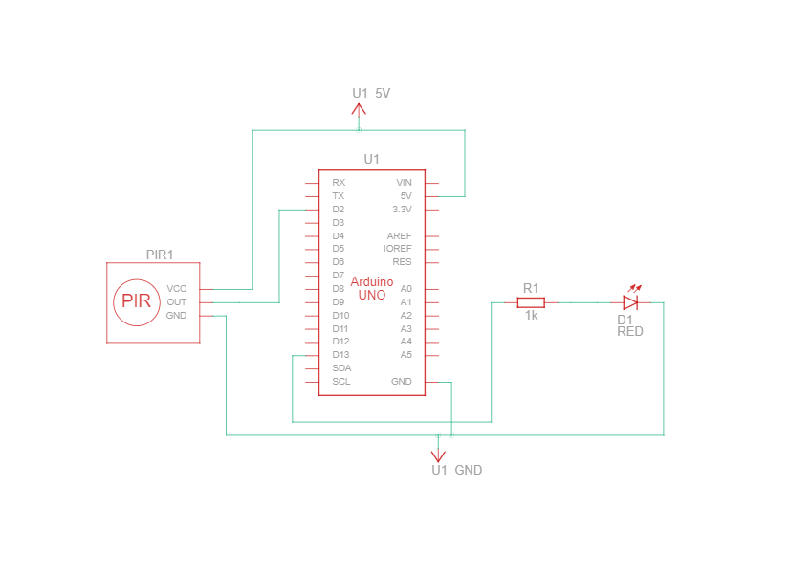

|  |  |  |
| --- | --- | --- |
| Output:- (you circuit implementation |  |  |

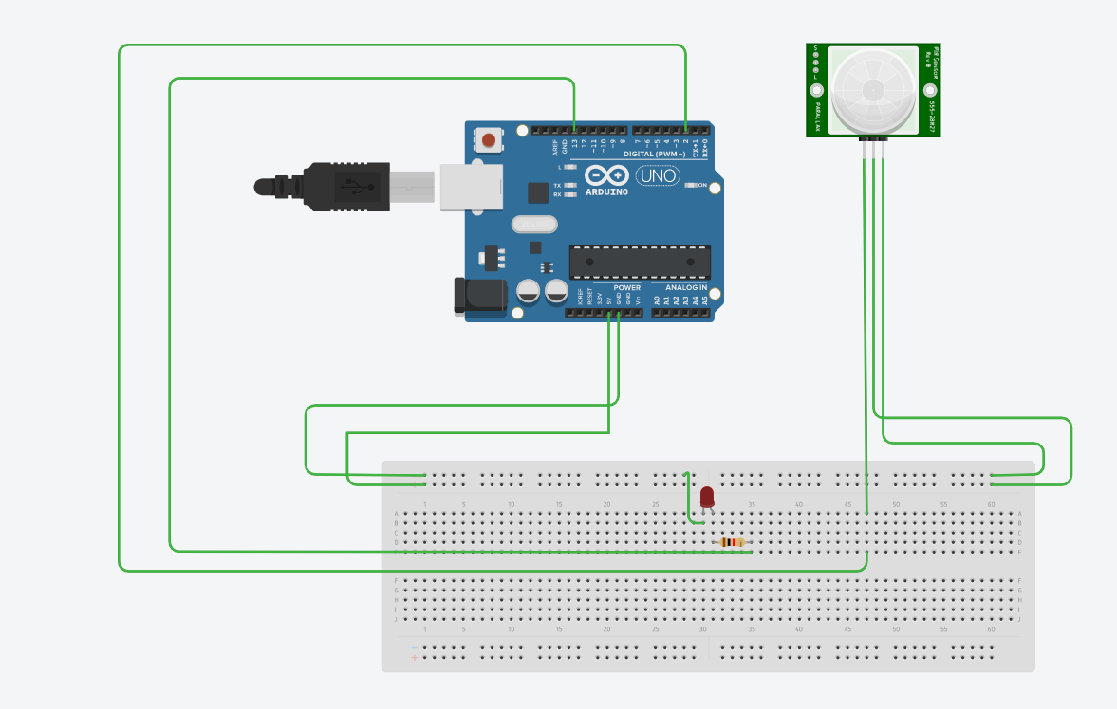

|  |  |
| --- | --- |
| Application:- |  |

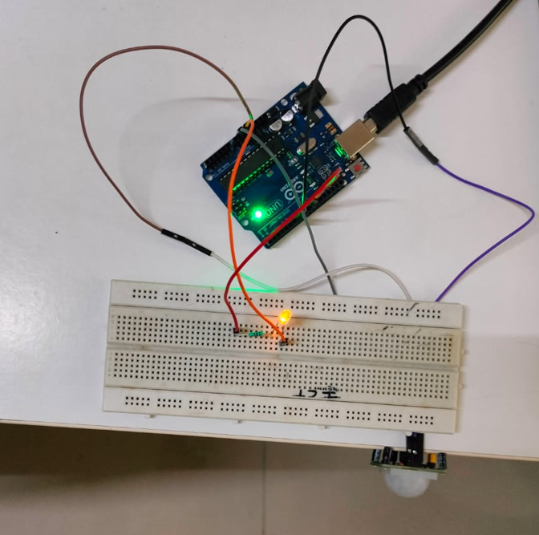

|  |  |
| --- | --- |
| Code:- |  |

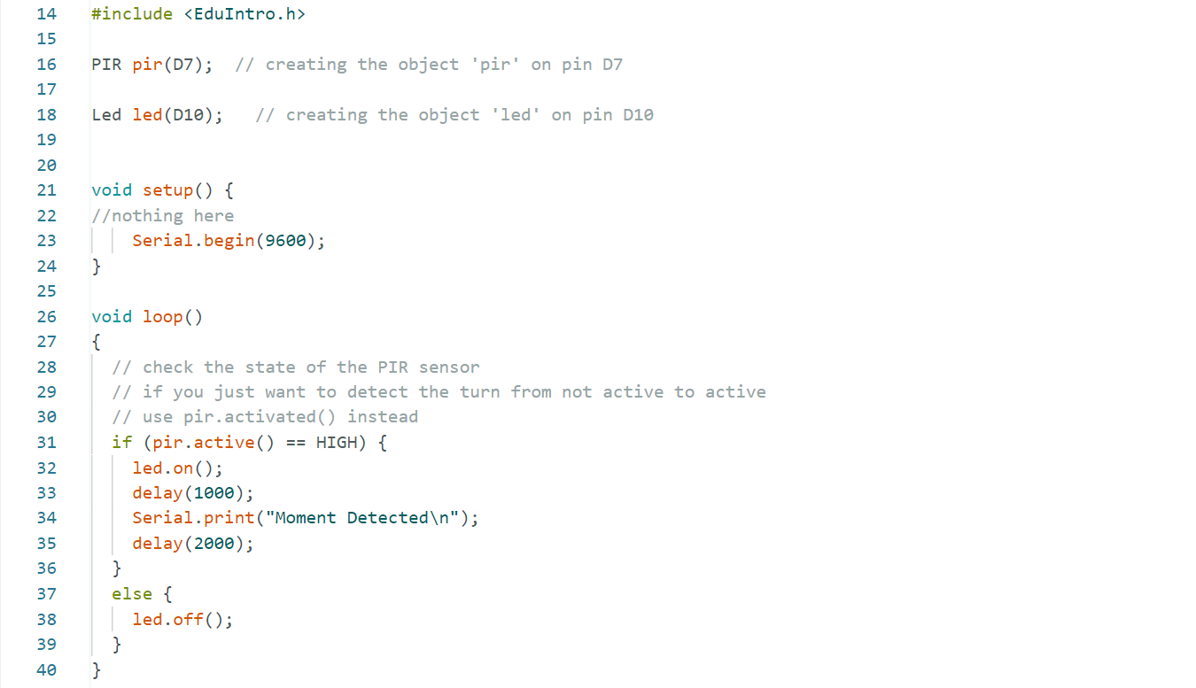

|  |  |
| --- | --- |
| Serial Monitor Readings:- |  |

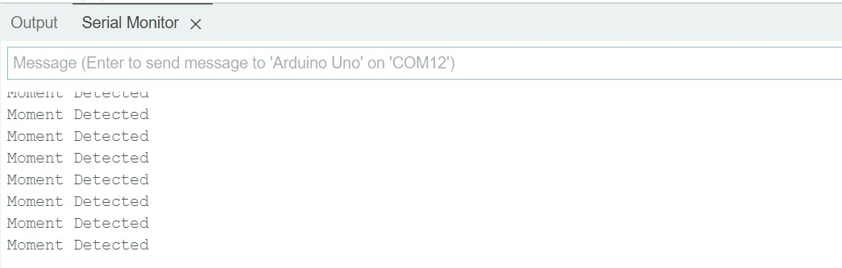

|  |  |
| --- | --- |
| Conclusion:- |  |

* In This Experiment, We Learnt That How To Interface PIR Sensor with Arduino. And how to detect motion.